Real-Time Self-Localization using Model-Based Matching
for Autonomous Robot of RoboCup MSL
Kaori Watanabe
Graduate School of Engineering, Tokyo Polytechnic University, 1583 Iiyama,
Atsugi, Kanagawa 243-0297, Japan
Yuehang Ma
Graduate School of Engineering, Tokyo Polytechnic University, 1583 Iiyama,
Atsugi, Kanagawa 243-0297, Japan
Hidekazu Suzuki
Faculty of Engineering, Tokyo Polytechnic University, 1583 Iiyama,
Atsugi, Kanagawa 243-0297, Japan
E-mail: watanabe.kougei.karakuri@gmail.com, xmaancn@gmail.com, hsuzuki@em.t-kougei.ac.jp
www.t-kougei.ac.jp

Abstract
This paper presents a self-localization technique using an omni-directional camera for an autonomous soccer robot. The position information of the robot is important for strategic behavior and cooperative operation. Therefore, we have proposed the self-localization method which generates the searching space based on a model-based matching with white line information of soccer field, and which recognizes the robot position by optimizing the fitness function using Genetic Algorithm.
Keywords: Self-Localization, RoboCup Middle Size League, Soccer Robot, Genetic Algorithm
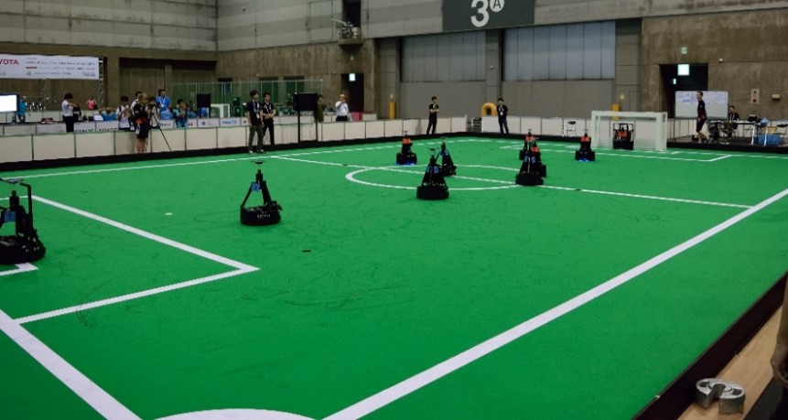
Fig. 1. RoboCup MSL

Introduction
The main focus of the RoboCup competitions is the game of football/soccer, where the research goals concern cooperative multi-robot and multi-agent systems in dynamic adversarial environments¹. In the field of RoboCup, self-localization technique is important to estimate own position including goal and other robot positions and to decide strategy. Basically, we estimate the self-position with the image information, the environment information and the field information. In this paper, we describe a real-time self-localization method that applies a genetic algorithm (GA) for the RoboCup middle size league (MSL, Fig. 1), which has the widest field size (12x18 m). In Section 2 is hardware structure, which is overview of our past robot, driving module, ball handling module and kicking module. In section 3, vision systems, which are omni-directional camera module and self-localization method are described. And we verify the effectiveness of the proposed self-localization method using GA in section 4.

Hardware structure
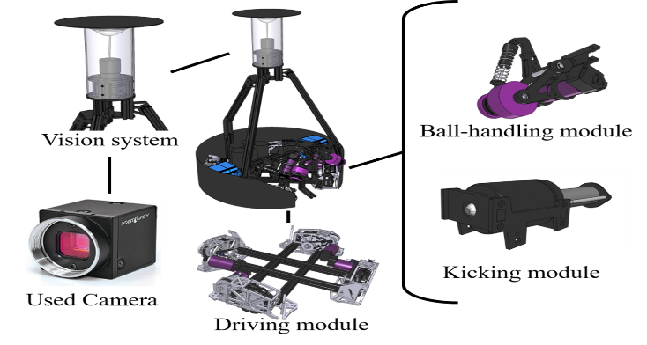
Fig. 2. $“$Mugen III$”$ Mechanical layout

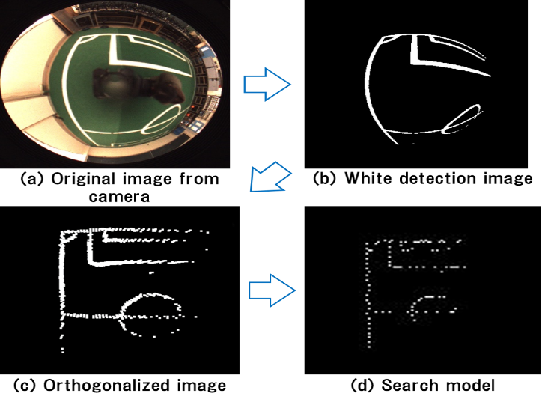
Fig. 3. Process of making search model

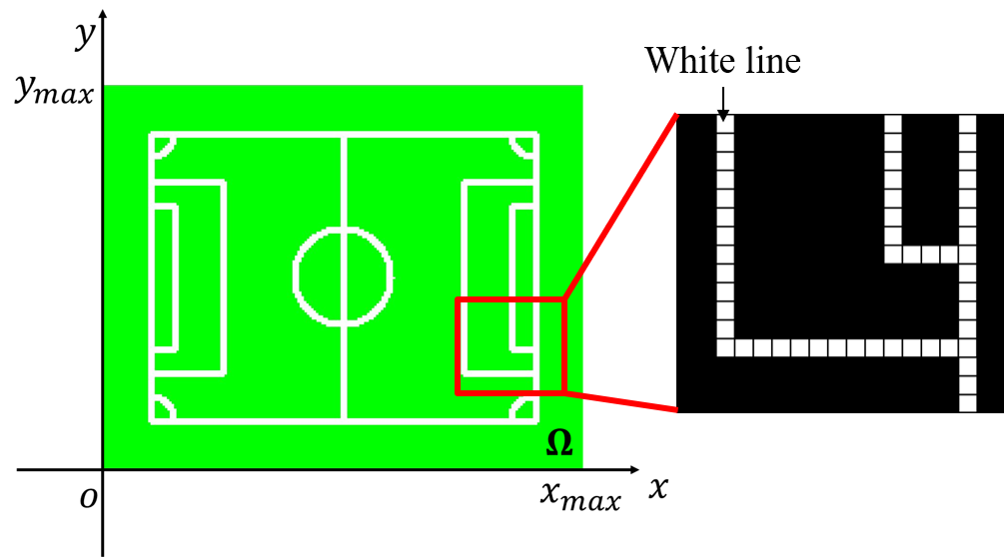
Fig. 4. Matching area

We have restructured the most part of hardware structure every year since our team was founded in 2008. We developed the robot based on recent MSL concepts that are high torque driving module, ball handling module, electrical kicking module using solenoid and USB3.0 camera system. We have called the platform as $“$Mugen$”$ series², and $“$Mugen III(M-III)$”$ shown in Fig. 3, which is improved and based on $“$Mugen$”$ model, participated in RoboCup Japan Open 2017.
This high torque driving module equips 4-wheels and each wheel is Omni directional wheel. We use ball handling module for rotating a ball with natural direction. This kicking module can shoot a ball by solenoid.

Vision system

Hardware of vision system
The omni-directional vision system of our robot is consisted of the camera (FLIR, Flea3³), a varifocal lens (Vstone) and a hyperboloidal mirror (Vstone). We developed vision system shown in Fig. 2 for RoboCup MSL robot by combining with above elements. The image captured by this vision system is shown in Fig. 3(a), and the image size and frame rate are 512 $×$ 512 [pixels] and 30 [fps] respectively.

Self-localization
We employ a white line of MSL field for self-localization. We have proposed the self-localization method which generates the searching space based on a model-based matching using white line information, and which recognizes the robot position by optimizing the fitness function which has the correct robot position as the maximum value of the function. And this proposed self-localization method employs Genetic Algorithm (GA)⁵ for optimization of the fitness function.

3.2.1. Searching model
Figure 3 shows the process of making the searching model of the proposed method. At first, we need the detection image of the white line for making the searching model based on the white line. We obtain the white detection image by employing the converting method of color space from RGB to HSV and to YUV like Fig. 3(b). And we generate the field information by orthogonalizing the white line information like Fig. 3(c). Moreover, we determine the searching model by thinning down the field information based on white line like Fig. 3(d). Therefor we use thinned model as searching model for the self-localization.
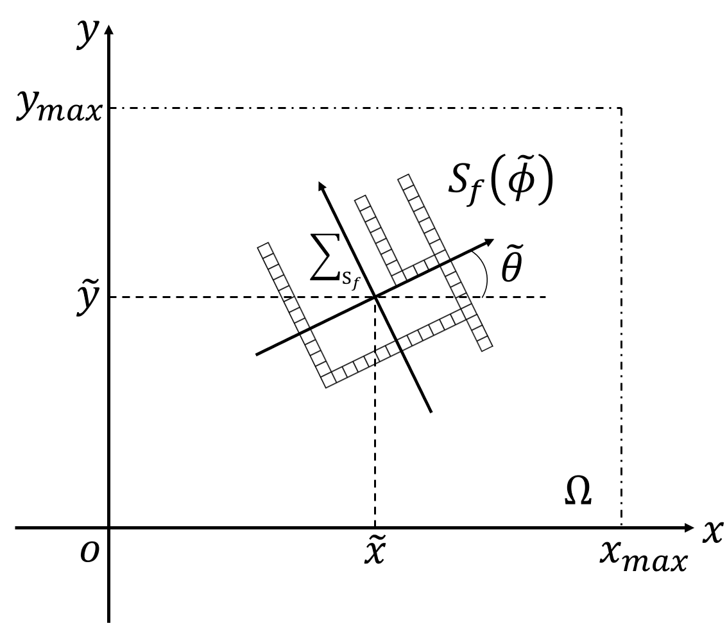
Fig. 5. Moving model

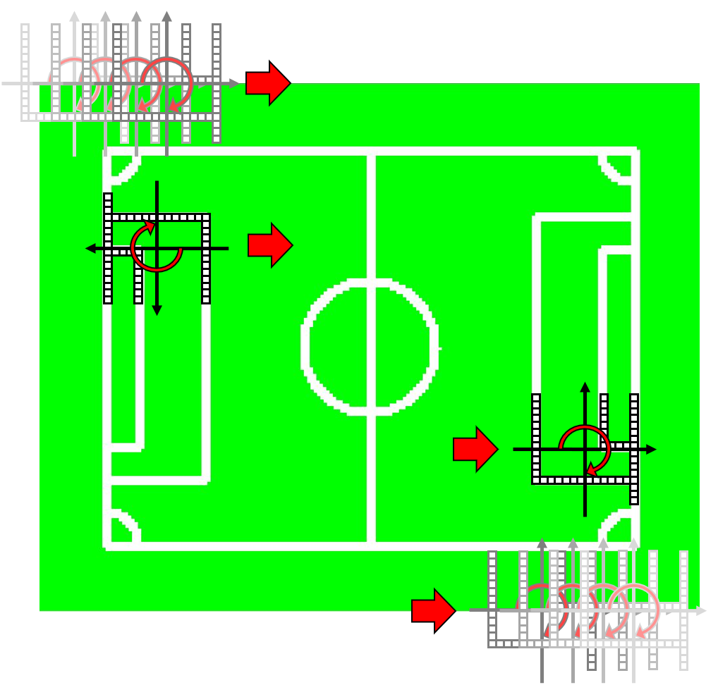
Fig. 6. Model matching

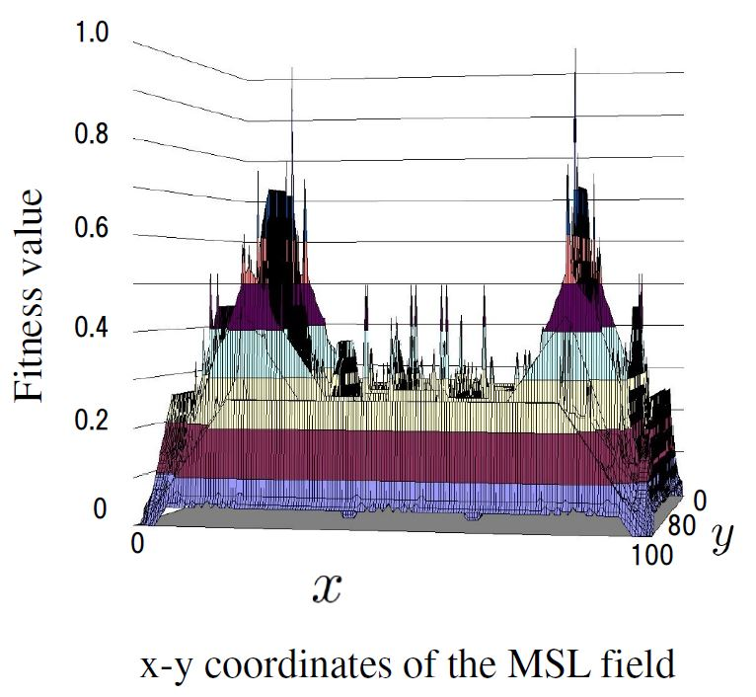
Fig. 7. Calculation result of the fitness function

3.2.2. Model-based matching
The proposed self-localization method generates the searching space by model-based matching between geometric information of the white line in the MSL field and above-mentioned searching model. Here, the matching area $Ω$ is MSL field, and white line in the field is expressed as set of pixels like Fig. 4. Therefore, the matching area $Ω$ is defined by following Eq. (1).
$$Ω=\left\{r=\left(x,y\right) | 0≤x≤x_{max},0≤y≤y_{max}\right\}$$ | (1)
Here, $x_{max}$and $y_{max}$are positive constant values corresponding to the image plane boundaries in x and y directions. Now let us consider the set of pixels with above-mentioned searching model shape inside $Ω$ as moving model $S_{f}$ like Fig. 5. The position $\tilde{r}=\left(\tilde{x}, \tilde{y}\right)$ and orientation $\tilde{θ}$ of moving model is represented as $\tilde{ϕ}={\left[\tilde{x}, \tilde{y}, \tilde{θ}\right]}^{T}$. Then the extent of the existence of the moving model is given by:
$Γ=\left\{\tilde{ϕ}=\left(\tilde{x}, \tilde{y}, \tilde{θ}\right)∈R^{3} | \tilde{r}∈Ω,-π<\tilde{θ}≤π \right\}$ | (2)
The movement of the moving model $S_{f}$ in the matching area is expressed as $S_{f}\left(\tilde{ϕ}\right)$. And, if the pixel value of field image corresponding to the area of the moving model is expressed as $p\left(\tilde{r}\right)$, $\tilde{r}∈S_{f}\left(\tilde{ϕ}\right)$, then the evaluation function $F\left(\tilde{ϕ}\right)$ of the moving model is given as follows.
$$F\left(\tilde{ϕ}\right)=\sum_{\tilde{r}∈S_{f}\left(\tilde{ϕ}\right)}{p\left(\tilde{r}\right)}$$ | (3)
The fitness function $F\left(\tilde{ϕ}\right)$ obtains the maximum value when the position and orientation of the moving model corresponds to the correct position and orientation that robot exist in the MSL field. Then, the problem of detection of robot position and orientation is changed to the problem of searching $\tilde{ϕ}$ that maximizes $F\left(\tilde{ϕ}\right)$, and can be expressed as:
$$find \tilde{ϕ} to maximize F\left(\tilde{ϕ}\right) subject to \tilde{ϕ}∈Γ$$ | (4)
The calculation result of whole matching area shown in Fig. 6 shows Fig. 7. In this Fig. 7, the vertical axis represents the fitness value, and the horizontal axes represent the field plane. Here, we select only one depending on the value of an electric compass, because two maximum value exist in the function value caused by revolution symmetry of geometric characters of the MSL field.

3.2.3. Verification of model-based matching
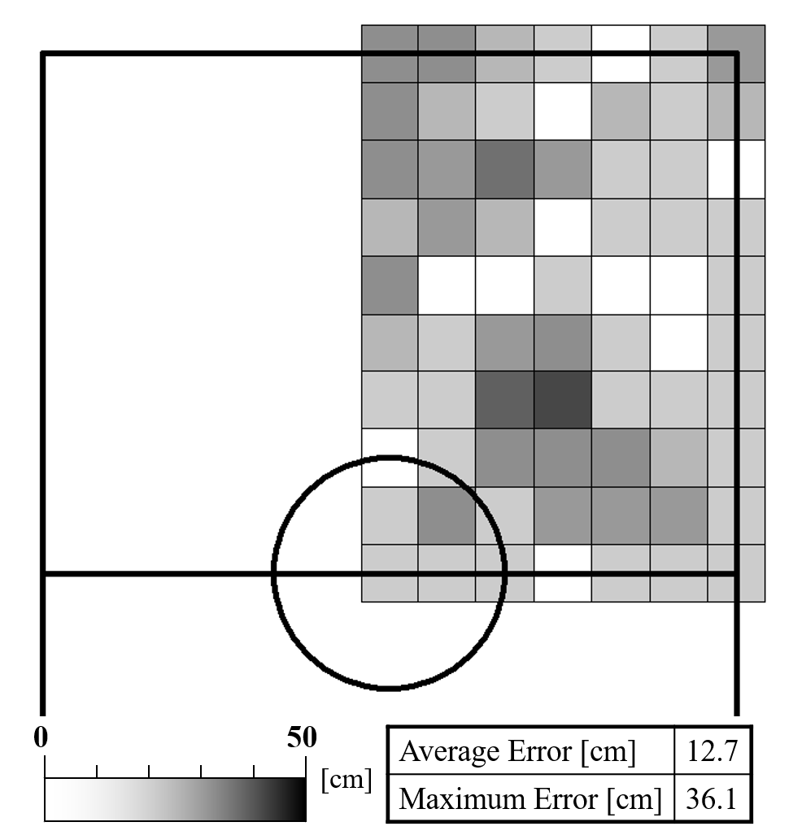
Fig. 8. Error of the self-localization using whole searching

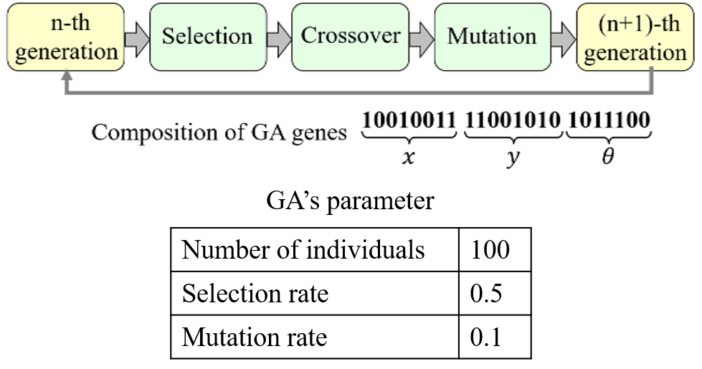
Fig.9. GA’s process

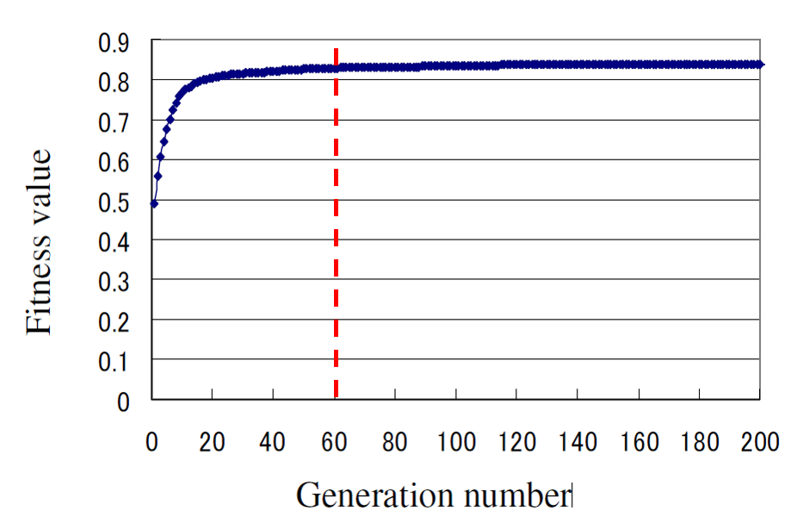
Fig. 10. Result of the convergence of GA

We performed an experiment to verify the effectiveness of the proposed model-based matching. Figure 8 shows the error between the correct position and the detected position in the quarter area of the MSL field at an interval of one meter. The severity of the error amount is indicated by the brightness of the gray scale. The average error was 12.7 [cm], so the self-localization method is accurate enough for playing soccer.
However, the processing time of whole searching for matching area $Ω$ is 3000 [ms]. So, we have needed the efficient searching method for real-time self-localization.

Real-time self-localization method

Genetic Algorithm
In the proposed self-localization method, we employ Genetic Algorithm (GA) for searching the maximum value of the fitness function $F\left(\tilde{ϕ}\right)$. A GA is an example of an artificial intelligence program and is well known as a parallel search and optimization process that mimics natural selection and evolution (Fig. 9). In the proposed method, an elitist model of a GA that preserves the best individual in the population at every generation is utilized and genetic coding using gray code, roulette selection and one-point crossover are employed. And, the parameters of the GA process are determined by previous experiments. Figure 10 shows the result of the convergence of GA in case of self-localization experiment using actual image that the robot captured at voluntary position. In this figure, the vertical axis represents fitness value of fitness function, and the horizontal axis represents the generation number of GA. The GA converged the maximum value, which means current position of robot in the MSL field, at about 60th generation in real-time.

Verification experiment using GA
We performed the self-localization experiment to verify the effectiveness of the proposed method using GA. Figure 11 shows the result of the verification experiment that checked the self-localization error using GA as same as Fig. 8. Average error of this experiment was 12.9 [cm], and the accuracy of the self-localization by the proposed method is roughly the same as the above-mentioned whole searching.
Moreover, we performed the experiment using five players shown in Fig. 12 on the assumption of MSL game. Laptop PC displays the position sent by each robot in real-time, and the positions of five players described in the result image corresponded with the actual position of the robots.

Conclusion
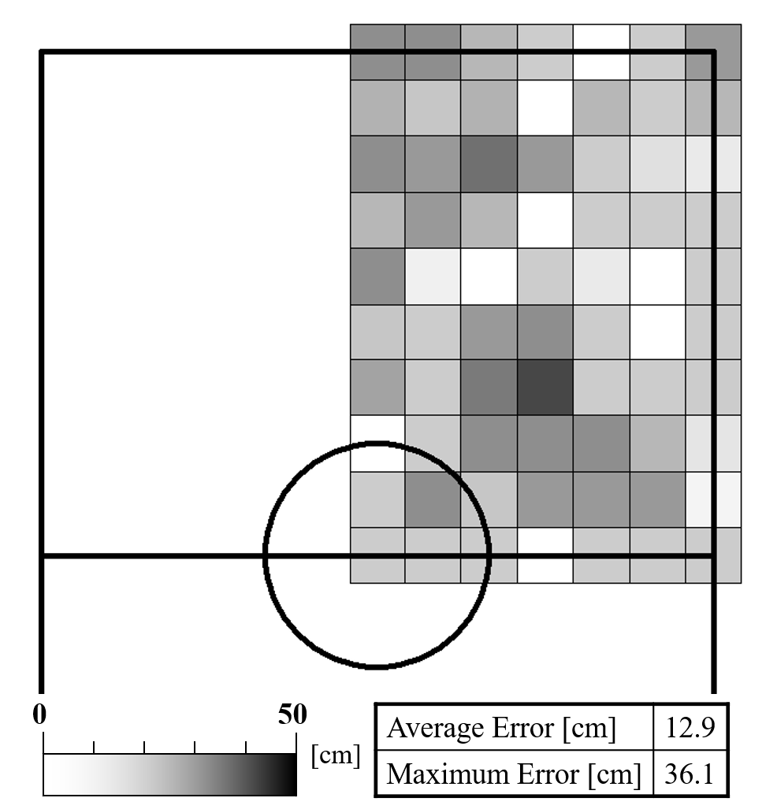
Fig. 11. Error of the self-localization using GA

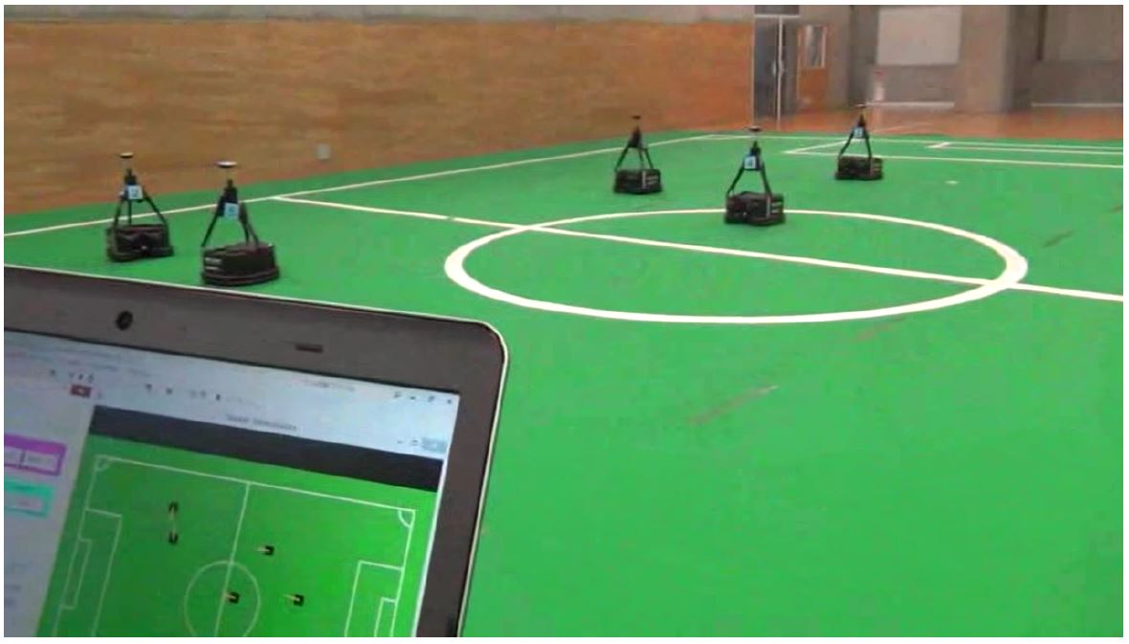
Fig. 12. Verification experiment in the real world

In this paper, we have proposed the self-localization method which generates the searching space based on a model-based matching with white line information of RoboCup MSL soccer field, and which recognizes the robot position by optimizing the fitness function using Genetic Algorithm. Moreover, we verified the effectiveness of the proposed self-localization method using GA. Furthermore, we confirmed that the accuracy of the self-localization by the proposed method is enough to play soccer.

Acknowledgment
This work was supported by $“$FY2016 MEXT Private University Research Branding Project$"$.

References
- $HYPERLINK "https://www.robocup.org/" “$RoboCup Federation official website,$”$, https://www.robocup.org/
- Y. Yasohara, H. Suzuki, $“$Development of Omni-directional Mobile Mechanism for RoboCup MSL$”$, Proceedings of 31st Fuzzy System Symposium, pp. 151-152, 2015. (In Japanese)
- FLIR, “Flea3(USB3 Vision Camera)”, https://www.flir.com/products/flea3-usb3/
- T. Yoshida, H. Suzuki, $“$Real-Time Self-Localization for RoboCup Middle-Size-League”, Proceedings 32nd Fuzzy System Symposium, pp. 397-398, 2016. (In Japanese)
- D.E.Goldberg, $“$Genetic Algorithms in Search, Optimization and Machine Learning$”$, Addison-Wesley, 1989.
- H. Suzuki, M. Minami, $“$Visual Servoing to Catch Fish Using Global/Local GA Search$”$, IEEE/ASME Transactions on Mechatronics, Vol. 10, No. 3, pp. 352-357, June, 2005.

Authors Introduction

Ms. Kaori Watanabe
She received her Master's degree from the Department of System Electronics and Information Science, Tokyo Polytechnic University, Japan in 2013. She is currently a Doctoral course student in Tokyo Polytechnic University, Japan.

Mr. Yuehang Ma
He received his B.S. degree in Engineering in 2018 from the Faculty of Engineering, Tokyo Polytechnic University in Japan. He is acquiring the M.E. in Tokyo Polytechnic University.

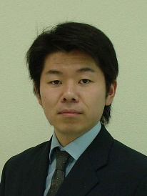
Dr. Hidekazu Suzuki
He is an Associate Professor of Faculty of Engineering at Tokyo Polytechnic University in Japan. He graduated from the Department of Mechanical Engineering, Fukui University, in 2000. He received his D. Eng. degree in System Design Engineering from Fukui University in 2005. His research interest is Robotics.

